Course: CMPT 743 Spring 2019

Assignment 01

Author: Lei Pan

**Active Contour and U-net Report**

The purpose of this assignment is for one part to implement active contour; and for another part to implement U-net structure and to train the U-net to segment medical images.

**I. Active Contour**

The active contour parameters are tuned according to different shapes.

**I.a Circle**

Our findFundamental method takes the set of points from the first image and the set of points from the second image, and starts by normalize all input points. Followed from that, we calculate the matrix of point2*point1 of each pair using the following code.

**I.b Shape**

**I.c Square**

Out findEssential function takes fundamental matrix and camera intrinsic matrix as inputs, and by the following line, we output essential matrix:

**I.d Star**

Running the two images given, we get our fundamental matrix.

Below are figures showing that our result is similar to openCV result.

**I.e Vase**

**I.f Dent**

**I.e Brain**

**–** The outer shell of the skull.

**–** The inner contour of the brain matter.

**–** The right eye hole.

*Figure 1 Our fundamental matrix*

**II. U-net**

I trained my network on GPU on images of size (572 * 572) , the same input size as the original net.

I used all the data augmentation strategies given in the assignment: flip, zoom, rotate, gamma correction, and elastic deformations. Furthermore, for each strategy, I provided different options such as flipping horizontally or vertically, rotate 90 or 180 degree more details can be seen in code. I also compared the tradeoff of different augmentation strategies (in chapter II.d). I deviated from the original network structure (with the ReLU in the last step) and compared both cases - with or without relu (in chapter II.b). I trained up to 30 epoches and found out that the results didn’t change much after 12 epoches. In epoch 12, the result is pretty good. For 12 epoches, the training time is about 15mins on sfucloud gpu. The comparison on different epoches can be seen in chapter II.e. Besides, I compared different learning rates (0.1 and 0.001), the result is in chapter II.f. The test data ratio is changed to 0.3 in order to have more test results. The test image accuracy is calculated according to different training conditions.

**II.a With vs Without Batch Normalization**

I compared the results under different batch normalization conditions. The neural networks are trained with same input images, and same training epoch 12. The learning rate is 0.001. No data augmentation is used for this comparison. The pixel-wise accuracy is calculated for each test image.

*Table 1 Comparison of results under different Batch Normalization conditions*

|  |  |  |  |
| --- | --- | --- | --- |
| Image Name | Accuracy (pixel-wise) | | |
| Without BN | With BN before ReLU | With BN after ReLU |
| BMMC_43.tif | 0.883 | 0.642 | 0.616 |
| BMMC_44.tif | 0.626 | 0.928 | 0.927 |
| BMMC_45.tif | 0.918 | 0.814 | 0.794 |
| BMMC_46.tif | 0.564 | 0.566 | 0.565 |
| BMMC_48.tif | 0.676 | 0.848 | 0.834 |
| BMMC_49.tif | 0.981 | 0.981 | 0.981 |
| BMMC_50.tif | 0.725 | 0.781 | 0.749 |
| BMMC_51.tif | 0.504 | 0.830 | 0.819 |
| BMMC_52.tif | 0.119 | 0.851 | 0.888 |
| BMMC_53.tif | 0.326 | 0.353 | 0.337 |
| Average | 0.632 | 0.759 | 0.751 |

We can see form the table above that, although our batch size is 1, with batch normalization, the accuracy is still higher as it can better center and normalize the image. I also noticed that batch normalization placed before ReLU is slightly better than placed after ReLU. Below are some examples of predicted results in the condition batch normalization placed before ReLU.

It can be seen that some ground truth labels are not very accurate, as it missed segmentation of some cells. The predict results can be even better than the ground truth(e.g BMMC_43.tif)

\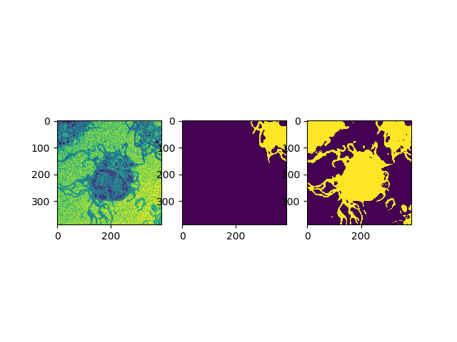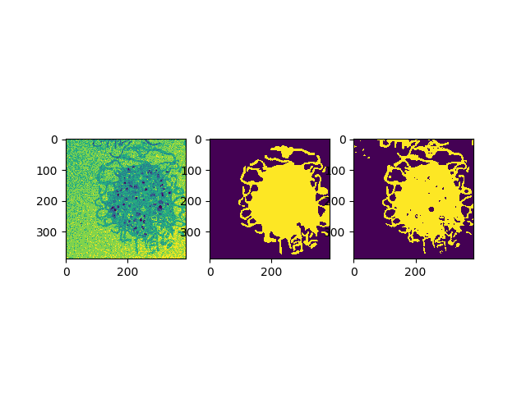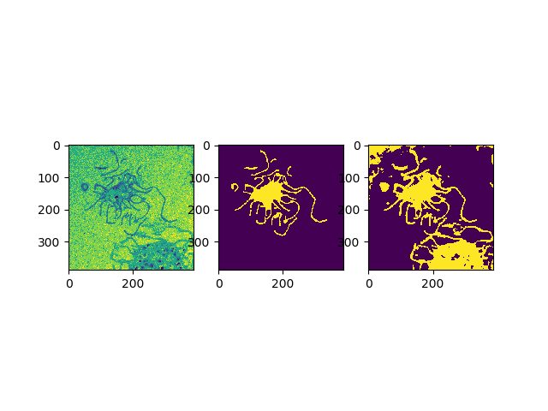

*Figure 1 Test results under condition batch normalization placed before ReLU*

*(from top to bottom BMMC_43.tif BMMC_43.tif BMMC_43.tif)*

**II.b With vs Without ReLU in the last step**

As mentioned before, I deviated from the original network structure and compared both cases - with or without the ReLU in the last step. The neural networks are trained with same training epoch 12. . The learning rate is 0.001. All data augmentation is used for this comparison.

*Table 2 Comparison of results on with or without ReLU in the last step*

|  |  |  |
| --- | --- | --- |
| Image Name | Accuracy (pixel-wise) | |
| Without ReLU | With  ReLU |
| BMMC_43.tif | 0.642 | 0.622 |
| BMMC_44.tif | 0.935 | 0.912 |
| BMMC_45.tif | 0.810 | 0.771 |
| BMMC_46.tif | 0.565 | 0.569 |
| BMMC_48.tif | 0.849 | 0.836 |
| BMMC_49.tif | 0.981 | 0.981 |
| BMMC_50.tif | 0.775 | 0.761 |
| BMMC_51.tif | 0.831 | 0.818 |
| BMMC_52.tif | 0.871 | 0.865 |
| BMMC_53.tif | 0.347 | 0.370 |
| Average | 0.761 | 0.751 |

We can see form the table above that, not use ReLU in the last step is slightly better. The difference is not that much.

Below are some test results of using ReLU in the last step. Same test images are choosen for comparison.

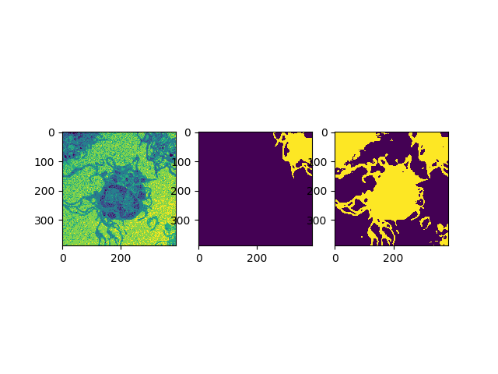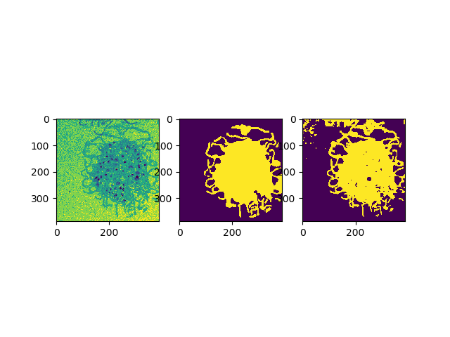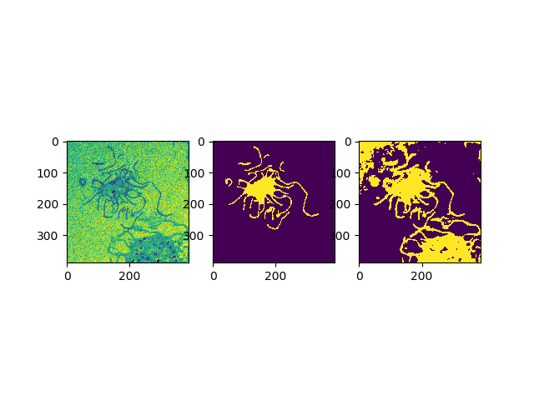

*Figure 2 Test results under condition using ReLU in the last step*

*(from top to bottom BMMC_43.tif BMMC_43.tif BMMC_43.tif)*

**II.c With vs Without Data Augmentation Strategies**

In this part, I compare with all data augmentation strategies case with without any data augmentation. In the next part, I compare the results of using different data augmentation strategies. The neural networks are trained with same training epoch 12 and also epoch 18, as I want to train more epochs to see changes in this case. The learning rate is 0.001.

*Table 3 Comparison of results on with or without data augmentation strategies*

|  |  |  |  |  |
| --- | --- | --- | --- | --- |
| Image Name | Accuracy (pixel-wise) | | | |
| With Data Aug(12 epochs) | Without Data Aug(12 epochs) | With Data Aug  (18 epochs) | Without Data Aug(18 epochs) |
| BMMC_43.tif | 0.642 | 0.642 | 0.667 | 0.643 |
| BMMC_44.tif | 0.935 | 0.928 | 0.942 | 0.922 |
| BMMC_45.tif | 0.810 | 0.814 | 0.843 | 0.768 |
| BMMC_46.tif | 0.565 | 0.566 | 0.564 | 0.568 |
| BMMC_48.tif | 0.849 | 0.848 | 0.855 | 0.839 |
| BMMC_49.tif | 0.981 | 0.981 | 0.981 | 0.981 |
| BMMC_50.tif | 0.775 | 0.781 | 0.788 | 0.759 |
| BMMC_51.tif | 0.831 | 0.830 | 0.835 | 0.811 |
| BMMC_52.tif | 0.871 | 0.851 | 0.931 | 0.908 |
| BMMC_53.tif | 0.347 | 0.353 | 0.327 | 0.363 |
| Average | 0.761 | 0.759 | 0.773 | 0.756 |

We can see form the table above that, using data augmention can increase the accuracy. The benefit is more obvious when training with more epochs as it fakes more training data.

Below are some test results of using data augmentation. Same test images are choosen for comparison.

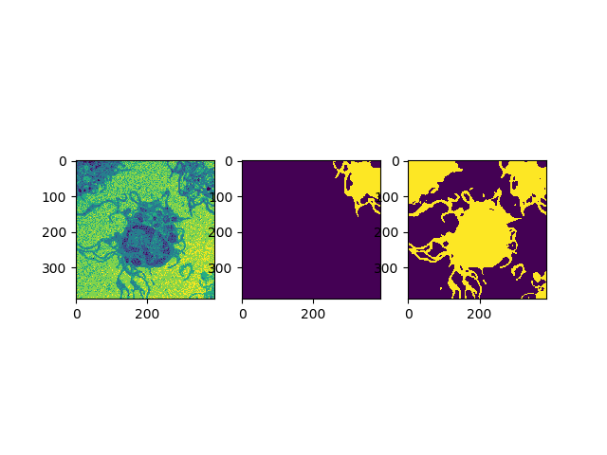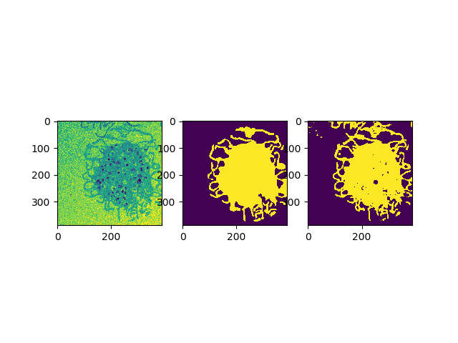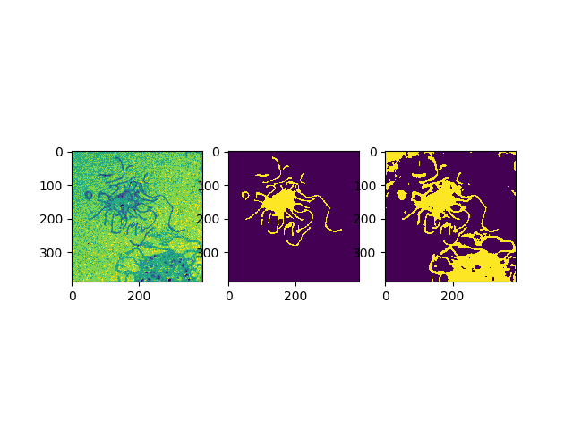

*Figure 2 Test results using Data Augmentation Strategy*

*(from top to bottom BMMC_43.tif BMMC_43.tif BMMC_43.tif)*

**II.d Comparison on Different Data Augmentation Strategies**

I tried different data augmentation strategies with different options.

* Flip the image horizontally or vertically
* Zoom the image by 1/0.95 or 1/0.9
* Rotate the image 90 or 180 degree
* Gamma correction 0.8
* Elastic deformations with sigma in range (6, 12)

I applied each data augmentation strategy separately to compare the different characteristics of each augmentation strategy. The neural networks are trained with same training epoch 12. The learning rate is 0.1.

*Table 3 Comparison of results on different data augmentation strategies*

|  |  |  |  |  |  |
| --- | --- | --- | --- | --- | --- |
| Image Name | Accuracy (pixel-wise) | | | | |
| Flip | Zoom | Rotate | Gamma | Elastic deformation |
| BMMC_52.tif | 0.930 | 0.884 | 0.863 | 0.930 | 0.935 |
| BMMC_53.tif | 0.674 | 0.430 | 0.383 | 0.755 | 0.915 |
| BMMC_7.tif | 0.708 | 0.851 | 0.864 | 0.708 | 0.751 |
| Average | 0.771 | 0.722 | 0.703 | 0.798 | 0.867 |

We can see from the table that we may be able to benefit more from elastic deformation strategy. Especially for the prediction result of BMMC_53.tif, the benefit is significant. As our dataset is limited and also fake training data is generated randomly, to draw a more precise conclusion, we need more information on that.

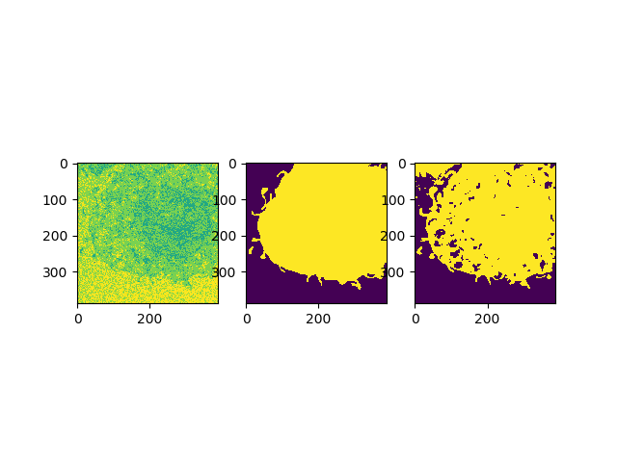

*Figure 2 Test results using only elastic deformation strategy (BMMC_53.tif)*

**II.e Comparison on Different Epochs**

I compared the test result on different training epochs. The data is trained up to 30 epochs. All data augmentation is used in order to generate better weights. The learning rate is 0.001.

*Table 3 Comparison of results on different epochs*

|  |  |  |  |
| --- | --- | --- | --- |
| Image Name | Accuracy (pixel-wise) | | |
| Epochs 12 | Epochs 18 | Epochs 30 |
| BMMC_43.tif | 0.642 | 0.667 | 0.682 |
| BMMC_44.tif | 0.935 | 0.942 | 0.953 |
| BMMC_45.tif | 0.810 | 0.843 | 0.841 |
| BMMC_46.tif | 0.565 | 0.564 | 0.566 |
| BMMC_48.tif | 0.849 | 0.855 | 0.858 |
| BMMC_49.tif | 0.981 | 0.981 | 0.981 |
| BMMC_50.tif | 0.775 | 0.788 | 0.770 |
| BMMC_51.tif | 0.831 | 0.835 | 0.827 |
| BMMC_52.tif | 0.871 | 0.931 | 0.959 |
| BMMC_53.tif | 0.347 | 0.327 | 0.333 |
| Average | 0.761 | 0.773 | 0.777 |

We can see that the average accuracy increases with more epochs. Due to the limit time and GPU, most of my test results are obtained based on 12 epochs.

**II.f Comparison on Different Learning Rate**

Finally, I compared the test result on different learning rate (0.001 and 0.01) with or without data augmentation. The training epoch is 12.

*Table 3 Comparison of results on different learning rates*

|  |  |  |  |  |
| --- | --- | --- | --- | --- |
| Image Name | Accuracy (pixel-wise) | | | |
| With Data Aug  lr=0.001 | With Data Aug  lr=0.1 | Without Data Aug  lr=0.001 | Without Data Aug  lr=0.1 |
| BMMC_43.tif | 0.642 | 0.643 | 0.642 | 0.265 |
| BMMC_44.tif | 0.935 | 0.921 | 0.928 | 0.564 |
| BMMC_45.tif | 0.810 | 0.793 | 0.814 | 0.271 |
| BMMC_46.tif | 0.565 | 0.568 | 0.566 | 0.834 |
| BMMC_48.tif | 0.849 | 0.845 | 0.848 | 0.584 |
| BMMC_49.tif | 0.981 | 0.981 | 0.981 | 0.955 |
| BMMC_50.tif | 0.775 | 0.776 | 0.781 | 0.370 |
| BMMC_51.tif | 0.831 | 0.824 | 0.830 | 0.689 |
| BMMC_52.tif | 0.871 | 0.864 | 0.851 | 0.930 |
| BMMC_53.tif | 0.347 | 0.364 | 0.353 | 0.795 |
| Average | 0.761 | 0.758 | 0.759 | 0.626 |

We can see that the average accuracy under learning rate 0.001 is higher than that under learning rate 0.1. With data augmentation, the result is better and the influence of learning rate is smaller.

**III. Bonus**

**III.a Internal Energy**

I implemented the internal energy calculation method. More details can be found in code.